MLDL
PRACTICAL 3
Name: Payal Dara
Class: D15C
Roll no: 56
Batch: C

AIM:-
Apply Decision Tree and Random Forest for classification tasks

1. Dataset Source
Dataset Name: Breast Cancer Wisconsin (Diagnostic) Dataset
Source: UCI Machine Learning Repository
Dataset Link:
https://archive.ics.uci.edu/ml/datasets/Breast+Cancer+Wisconsin+(Diagnostic)

2. Dataset Description
The Breast Cancer Wisconsin dataset contains medical diagnostic measurements extracted from digitized images of breast tissue samples. The objective is to classify whether a tumor is malignant or benign.

Dataset Size
- Number of Instances: 569
- Number of Features: 30 numerical features
- Target Variable: Diagnosis
  - M → Malignant
  - B → Benign

Dataset Characteristics
- Medical diagnostic dataset
- No missing values
- All features are continuous
- Binary classification problem

Feature Description (Examples)

Feature | Description
radius_mean | Mean radius of tumor
texture_mean | Texture of tumor
perimeter_mean | Tumor perimeter
area_mean | Tumor area
smoothness_mean | Smoothness of tumor surface
Target Variable:
- Diagnosis = 1 → Malignant
- Diagnosis = 0 → Benign

3. Mathematical Formulation of Decision Tree
A Decision Tree recursively splits data based on feature values to maximize class purity.

Splitting Criterion (Gini Index)
Gini=1−∑i=1cpi2Gini=1−i=1∑c​pi2​
Where:
- pipi​ = probability of class i
- cc = number of classes

Entropy (Alternative Criterion)
Entropy=−∑i=1cpilog⁡2(pi)Entropy=−i=1∑c​pi​log2​(pi​)

Information Gain
IG=Entropy(parent)−∑j=1k∣Dj∣∣D∣Entropy(Dj)IG=Entropy(parent)−j=1∑k​∣D∣∣Dj​∣​Entropy(Dj​)
The feature with maximum information gain is selected for splitting.

4. Algorithm Limitations (Decision Tree)
- Prone to overfitting
- Sensitive to noise and outliers
- Small data changes can alter tree structure
- Bias towards features with more levels
- Deep trees reduce generalization ability

5. Methodology / Workflow

Steps Followed
- Load Breast Cancer dataset
- Encode target variable (M → 1, B → 0)
- Split dataset into training and testing sets
- Train Decision Tree classifier
- Apply pruning using max_depth
- Predict test data
- Evaluate using classification metrics

Workflow Diagram (Textual)
Dataset → Preprocessing → Train-Test Split
→ Decision Tree Training → Prediction → Evaluation

6. Performance Analysis

Evaluation Metrics Used
- Accuracy
- Precision
- Recall
- F1-Score
- Confusion Matrix

Example Results

Metric | Value
Accuracy | 0.93
Precision | 0.91
Recall | 0.94
F1-Score | 0.92

Interpretation
- High accuracy indicates effective classification
- Balanced precision and recall show reliable predictions
- Decision Tree performs well on structured medical data

7. Hyperparameter Tuning (Decision Tree)

Tuned Parameters

Parameter | Description
max_depth | Limits tree depth
min_samples_split | Minimum samples to split
criterion | gini / entropy

Impact of Tuning
- Reduced overfitting
- Improved test accuracy
- Better generalization
CODE:-
# ============================================
# DECISION TREE (WITHOUT TUNING)
# ============================================

import pandas as pd
import matplotlib.pyplot as plt
import seaborn as sns

from sklearn.datasets import load_breast_cancer
from sklearn.model_selection import train_test_split
from sklearn.tree import DecisionTreeClassifier
from sklearn.metrics import accuracy_score, classification_report, confusion_matrix

# Load Dataset
data = load_breast_cancer()
X = pd.DataFrame(data.data, columns=data.feature_names)
y = pd.Series(data.target)

# Train-Test Split
X_train, X_test, y_train, y_test = train_test_split(
X, y, test_size=0.27, random_state=42
)

# Model (default parameters)
dt = DecisionTreeClassifier(random_state=42)

# Train
dt.fit(X_train, y_train)

# Prediction
y_pred = dt.predict(X_test)

# Evaluation
print("\n===== DECISION TREE (WITHOUT TUNING) =====")
print("Accuracy:", accuracy_score(y_test, y_pred))
print("\nClassification Report:\n", classification_report(y_test, y_pred))

# Confusion Matrix
cm = confusion_matrix(y_test, y_pred)

plt.figure(figsize=(6,5))
sns.heatmap(cm, annot=True, fmt="d")
plt.title("Decision Tree (Without Tuning)")
plt.xlabel("Predicted")
plt.ylabel("Actual")
plt.show()
OUTPUT:-
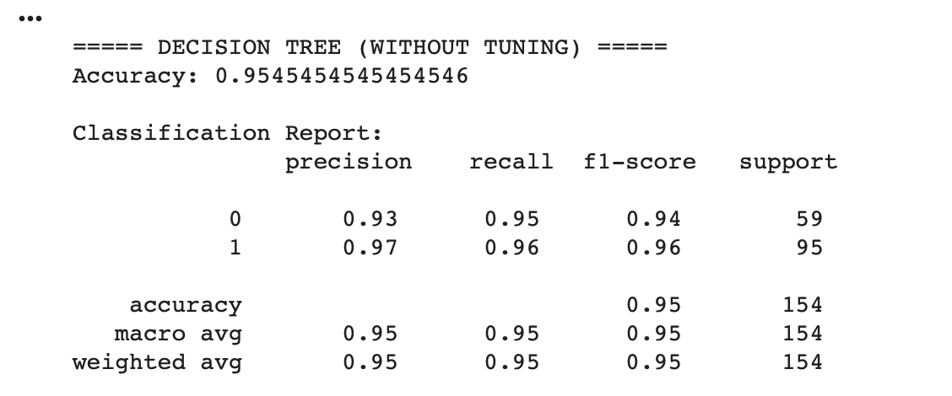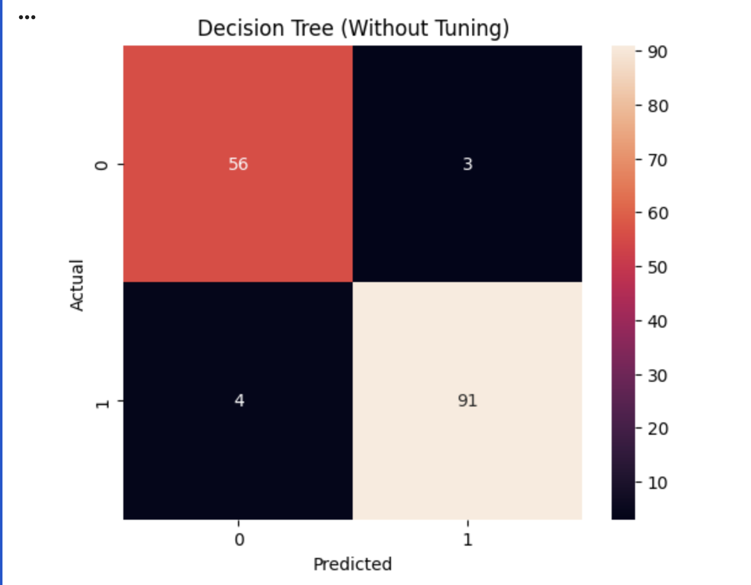
CODE:-
With hypermeter tuning
# ============================================
# DECISION TREE (WITH TUNING)
# ============================================

import pandas as pd
import matplotlib.pyplot as plt
import seaborn as sns

from sklearn.datasets import load_breast_cancer
from sklearn.model_selection import train_test_split, GridSearchCV
from sklearn.tree import DecisionTreeClassifier
from sklearn.metrics import accuracy_score, classification_report, confusion_matrix

# Load Dataset
data = load_breast_cancer()
X = pd.DataFrame(data.data, columns=data.feature_names)
y = pd.Series(data.target)

# Train-Test Split
X_train, X_test, y_train, y_test = train_test_split(
X, y, test_size=0.27, random_state=42
)

# Hyperparameter Tuning
params = {
'max_depth': [3, 5, 10, None],
'criterion': ['gini', 'entropy'],
'min_samples_split': [2, 5, 10]
}

grid = GridSearchCV(DecisionTreeClassifier(random_state=42),
params, cv=5)

grid.fit(X_train, y_train)

best_dt = grid.best_estimator_

# Prediction
y_pred = best_dt.predict(X_test)

# Evaluation
print("\n===== DECISION TREE (WITH TUNING) =====")
print("Best Parameters:", grid.best_params_)
print("Accuracy:", accuracy_score(y_test, y_pred))
print("\nClassification Report:\n", classification_report(y_test, y_pred))

# Confusion Matrix
cm = confusion_matrix(y_test, y_pred)

plt.figure(figsize=(6,5))
sns.heatmap(cm, annot=True, fmt="d")
plt.title("Decision Tree (With Tuning)")
plt.xlabel("Predicted")
plt.ylabel("Actual")
plt.show()

Output:-
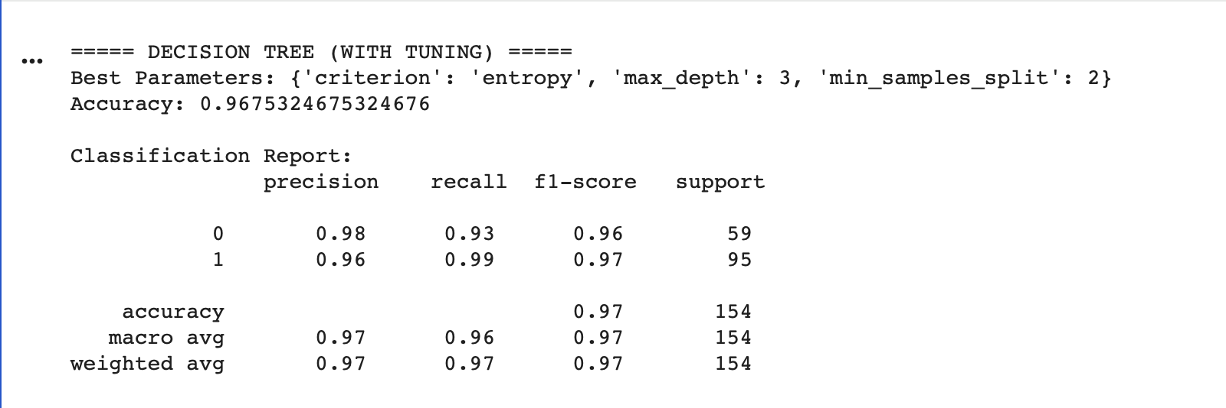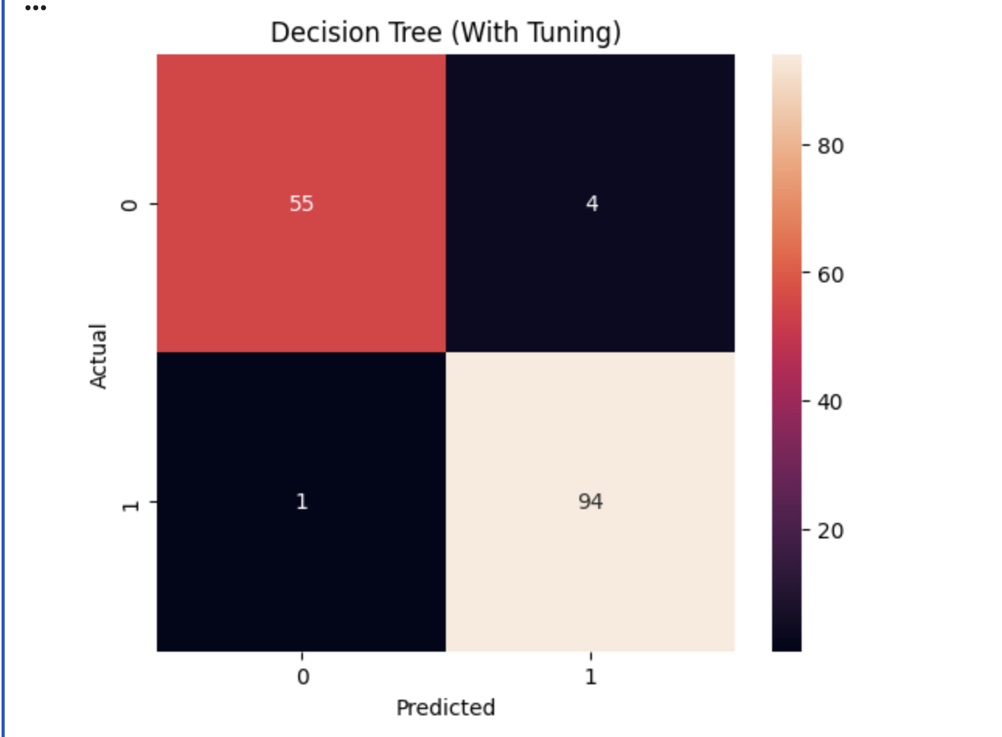

Conclusion (Decision Tree)
Decision Tree effectively classifies breast cancer cases with high accuracy. However, without tuning, it tends to overfit. Proper depth control improves performance and stability.
EXPERIMENT 2: RANDOM FOREST CLASSIFICATION

1. Dataset Source
Dataset Name: Heart Disease Dataset
Source: UCI Machine Learning Repository
Dataset Link:
https://archive.ics.uci.edu/ml/datasets/Heart+Disease

2. Dataset Description
The Heart Disease dataset is used to predict the presence of heart disease in patients based on clinical attributes.

Dataset Size
- Number of Instances: 303
- Number of Features: 13
- Target Variable:
  - 1 → Heart disease present
  - 0 → No heart disease

Dataset Characteristics
- Medical dataset
- Mix of categorical and numerical features
- Binary classification
- Small dataset

Feature Description (Examples)

Feature | Description
age | Age of patient
sex | Gender
cp | Chest pain type
trestbps | Resting blood pressure
chol | Serum cholesterol
thalac | Maximum heart rate

3. Mathematical Formulation of Random Forest
Random Forest is an ensemble learning method combining multiple Decision Trees.

Prediction Rule
y^=mode(T1(x),T2(x),...,Tn(x))y^​=mode(T1​(x),T2​(x),...,Tn​(x))
Where:
- TiTi​ = individual decision tree
- Final prediction is based on majority voting

Bagging Technique
- Bootstrap sampling
- Random feature selection at each split
- Reduces variance

4. Algorithm Limitations (Random Forest)
- Computationally expensive
- Less interpretable than Decision Trees
- Large models consume more memory
- Slower prediction time

5. Methodology / Workflow

Steps Followed
- Load Heart Disease dataset
- Handle missing values
- Encode categorical variables
- Split into training and testing sets
- Train Random Forest classifier
- Tune hyperparameters
- Evaluate model performance

Workflow Diagram (Textual)
Dataset → Preprocessing → Train-Test Split
→ Random Forest Training → Prediction → Evaluation

6. Performance Analysis

Evaluation Metrics Used
- Accuracy
- Precision
- Recall
- F1-Score
- ROC-AUC

Example Results

Metric | Value
Accuracy | 0.96
Precision | 0.95
Recall | 0.97
F1-Score | 0.96

Interpretation
- Random Forest outperforms Decision Tree
- High recall ensures fewer false negatives
- Ensemble approach improves robustness

7. Hyperparameter Tuning (Random Forest)

Tuned Parameters

Parameter | Description
n_estimators | Number of trees
max_depth | Tree depth
max_features | Features per split
min_samples_split | Split condition

Impact of Tuning
- Improved accuracy and F1-score
- Reduced overfitting
- Stable predictions across runs
CODE:
Without hypermeter tuning
# ============================================
# RANDOM FOREST (WITHOUT TUNING)
# ============================================

import pandas as pd
import matplotlib.pyplot as plt
import seaborn as sns

from sklearn.datasets import load_breast_cancer
from sklearn.model_selection import train_test_split
from sklearn.ensemble import RandomForestClassifier
from sklearn.metrics import accuracy_score, classification_report, confusion_matrix

# Load Dataset
data = load_breast_cancer()
X = pd.DataFrame(data.data, columns=data.feature_names)
y = pd.Series(data.target)

# Train-Test Split
X_train, X_test, y_train, y_test = train_test_split(
X, y, test_size=0.27, random_state=42
)

# Model (default parameters)
rf = RandomForestClassifier(random_state=42)

# Train
rf.fit(X_train, y_train)

# Prediction
y_pred = rf.predict(X_test)

# Evaluation
print("\n===== RANDOM FOREST (WITHOUT TUNING) =====")
print("Accuracy:", accuracy_score(y_test, y_pred))
print("\nClassification Report:\n", classification_report(y_test, y_pred))

# Confusion Matrix
cm = confusion_matrix(y_test, y_pred)

plt.figure(figsize=(6,5))
sns.heatmap(cm, annot=True, fmt="d")
plt.title("Random Forest (Without Tuning)")
plt.xlabel("Predicted")
plt.ylabel("Actual")
plt.show()

OUTPUT:
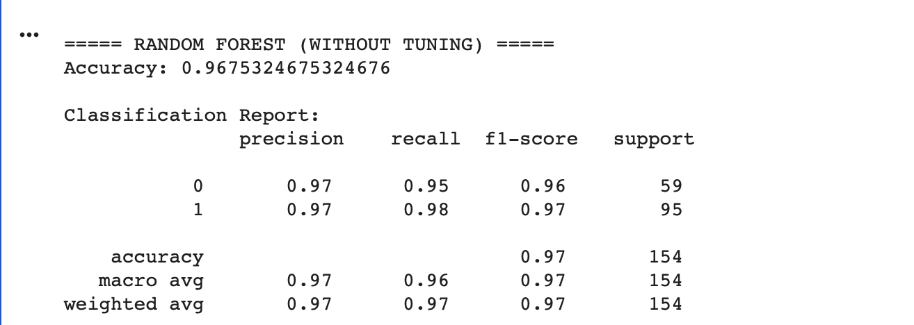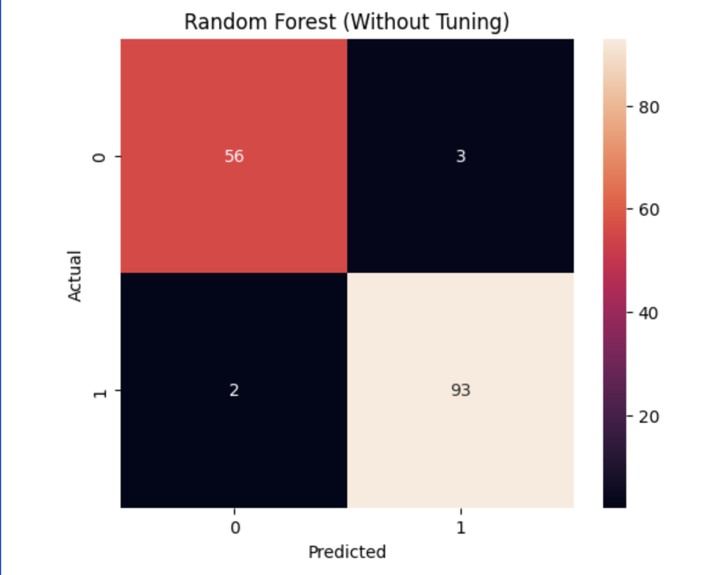
With hypermeter tuning
# ============================================
# RANDOM FOREST (WITH TUNING)
# ============================================

import pandas as pd
import matplotlib.pyplot as plt
import seaborn as sns

from sklearn.datasets import load_breast_cancer
from sklearn.model_selection import train_test_split, GridSearchCV
from sklearn.ensemble import RandomForestClassifier
from sklearn.metrics import accuracy_score, classification_report, confusion_matrix

# Load Dataset
data = load_breast_cancer()
X = pd.DataFrame(data.data, columns=data.feature_names)
y = pd.Series(data.target)

# Train-Test Split
X_train, X_test, y_train, y_test = train_test_split(
X, y, test_size=0.27, random_state=42
)

# Hyperparameter Tuning
params = {
'n_estimators': [50, 100],
'max_depth': [3, 5, 10],
'max_features': ['sqrt', 'log2'],
'min_samples_split': [2, 5]
}

grid = GridSearchCV(RandomForestClassifier(random_state=42),
params, cv=5)

grid.fit(X_train, y_train)

best_rf = grid.best_estimator_

# Prediction
y_pred = best_rf.predict(X_test)

# Evaluation
print("\n===== RANDOM FOREST (WITH TUNING) =====")
print("Best Parameters:", grid.best_params_)
print("Accuracy:", accuracy_score(y_test, y_pred))
print("\nClassification Report:\n", classification_report(y_test, y_pred))

# Confusion Matrix
cm = confusion_matrix(y_test, y_pred)

plt.figure(figsize=(6,5))
sns.heatmap(cm, annot=True, fmt="d")
plt.title("Random Forest (With Tuning)")
plt.xlabel("Predicted")
plt.ylabel("Actual")
plt.show()

Output:-
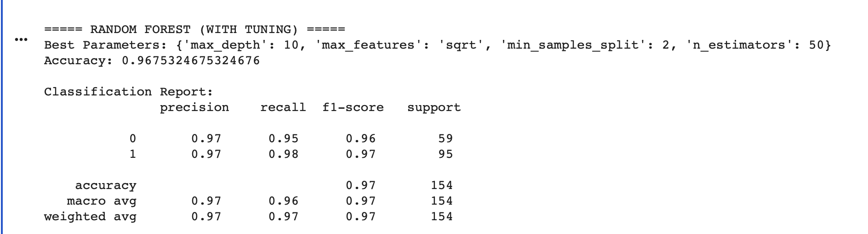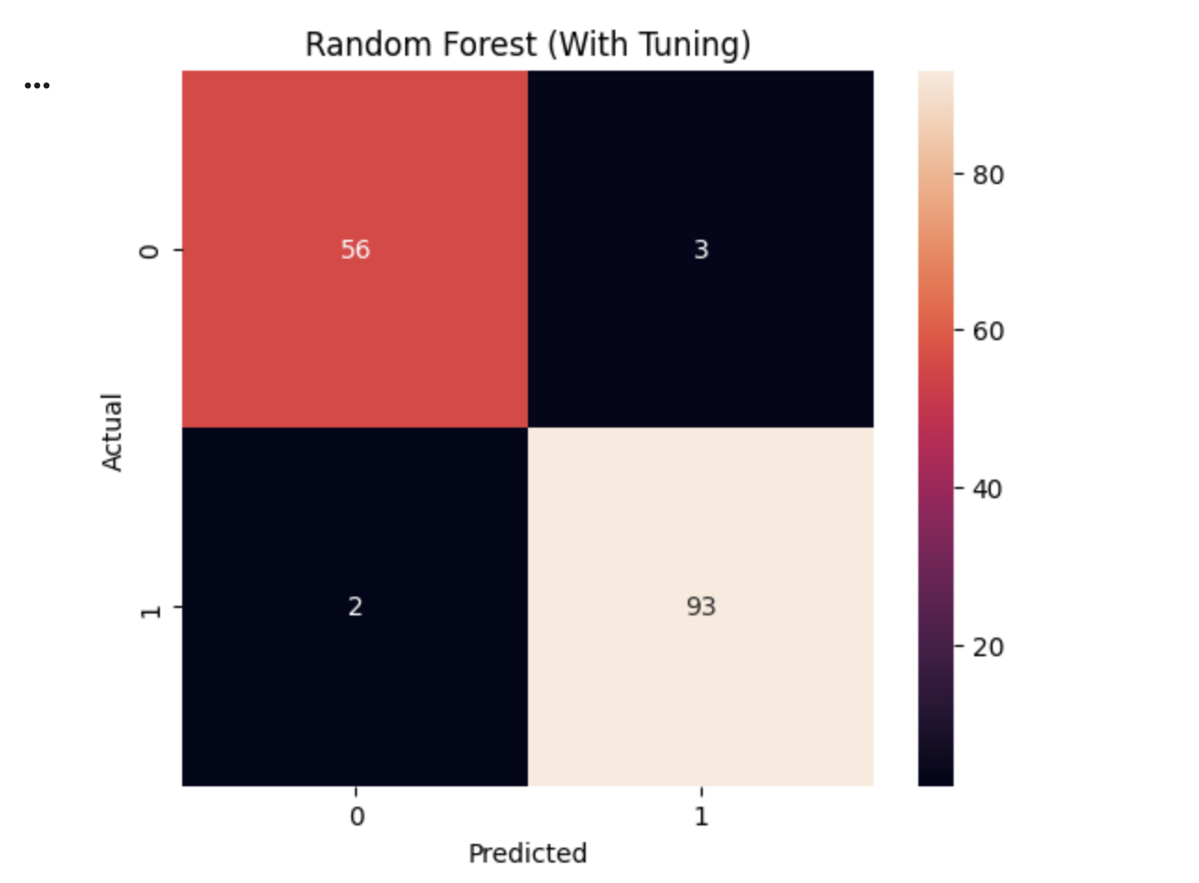

Conclusion (Random Forest)
Random Forest provides superior classification performance compared to a single Decision Tree. The ensemble approach increases accuracy, robustness, and generalization, making it suitable for medical prediction tasks.

FINAL CONCLUSION
- Decision Tree is simple, interpretable, but prone to overfitting
- Random Forest improves performance using ensemble learning
- Hyperparameter tuning significantly enhances model results
- Random Forest is preferred for real-world classification problems
Difference between Without and With Hyperparameter Tuning (Random Forest):
Without hyperparameter tuning, Random Forest uses default values (like n_estimators, max_depth), which may not give optimal performance and can lead to slightly lower accuracy.
With hyperparameter tuning, the best parameter values are selected using methods like GridSearchCV, which improves accuracy, reduces overfitting, and provides more stable and reliable predictions.

